2023 SATU SMART 國際創新競賽
提案募集中！高額獎金等你來贏取！

臺灣與東南亞暨南亞大學校長論壇（SATU）、成大國際事務處以及成大產學創新總中心合辦2023年 SATU SMART 國際新創競賽，歡迎 SATU 校長論壇會員校 的同學參加。如何透過生命科學實現永續？邀請您用小點子解決大問題！為環境的互利共好邁出積極的一步。
無須新創或創業經驗，也不限同學所屬專業領域。參賽同學有機會與來自不同國家的同學組隊，或自行組隊與來自其他國家的團隊互相交流切磋，以有創意又有潛力的提案，競逐總額超過30萬元的獎金。SATU 一年一度的重大盛事不容錯過，趕快動手報名吧！
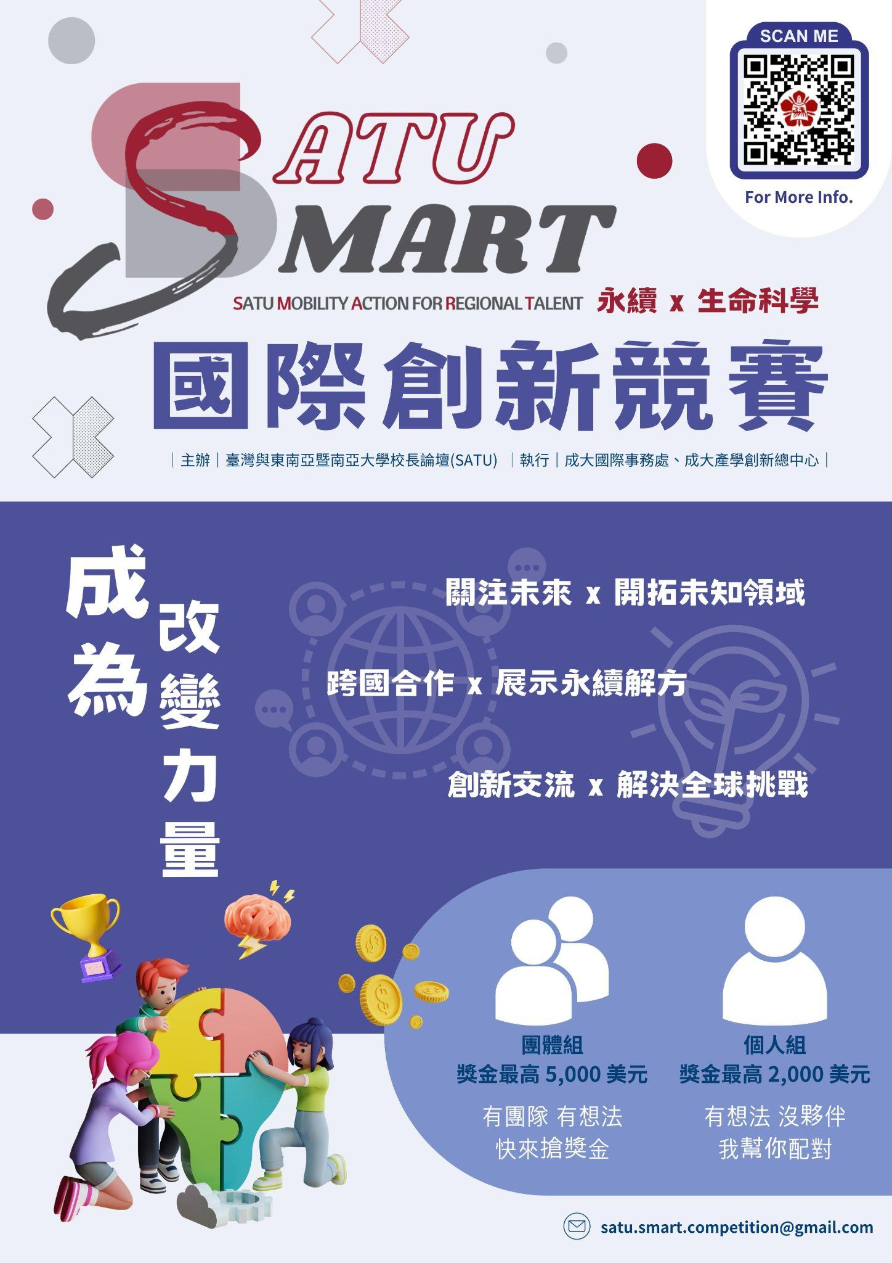
【參賽資格】
所有於 SATU 校長論壇會員校就讀的學生 (按此查看SATU校長論壇會員校名單)
【報名方式】
即日起至8月6日，更多詳細資訊請見 https://linktr.ee/satu.smart
- 個人報名
- 團體報名（2-5位）

【活動時程】
組隊結果公佈：2023/08/09
徵件截止日期：2023/10/05
決賽名單公佈：2023/10/30
決賽簡報發表：2023/11/04-11/05
成績公佈：2023/11/07
SATU 年會頒獎典禮 ：2023年11中旬（待公布）

【獎金】
個人報名組：
金獎：2,000美金
銀獎：1,000美金
銅獎：500美金

團隊報名組：
金獎：5,000美金
銀獎：3,000美金
銅獎：1,000美金

【聯絡窗口】
成大產學創新總中心 吳小姐
✉ satu.smart.competition@gmail.com
☎ 06-2757575 #36000-316 | 06-2360524 #316

2023 SATU SMART 5th International Innovation Competition [Register Now!]
The SATU Presidents’ Forum is excited to announce that the 2023 SATU SMART 5th International Innovation Competition is calling for application!

More than theories and tutorials. A calling for students to take action and save the world. An opportunity to learn while you do.

If you have any great ideas to change the world and want them to be seen but do not know where to start, this is the competition for you!

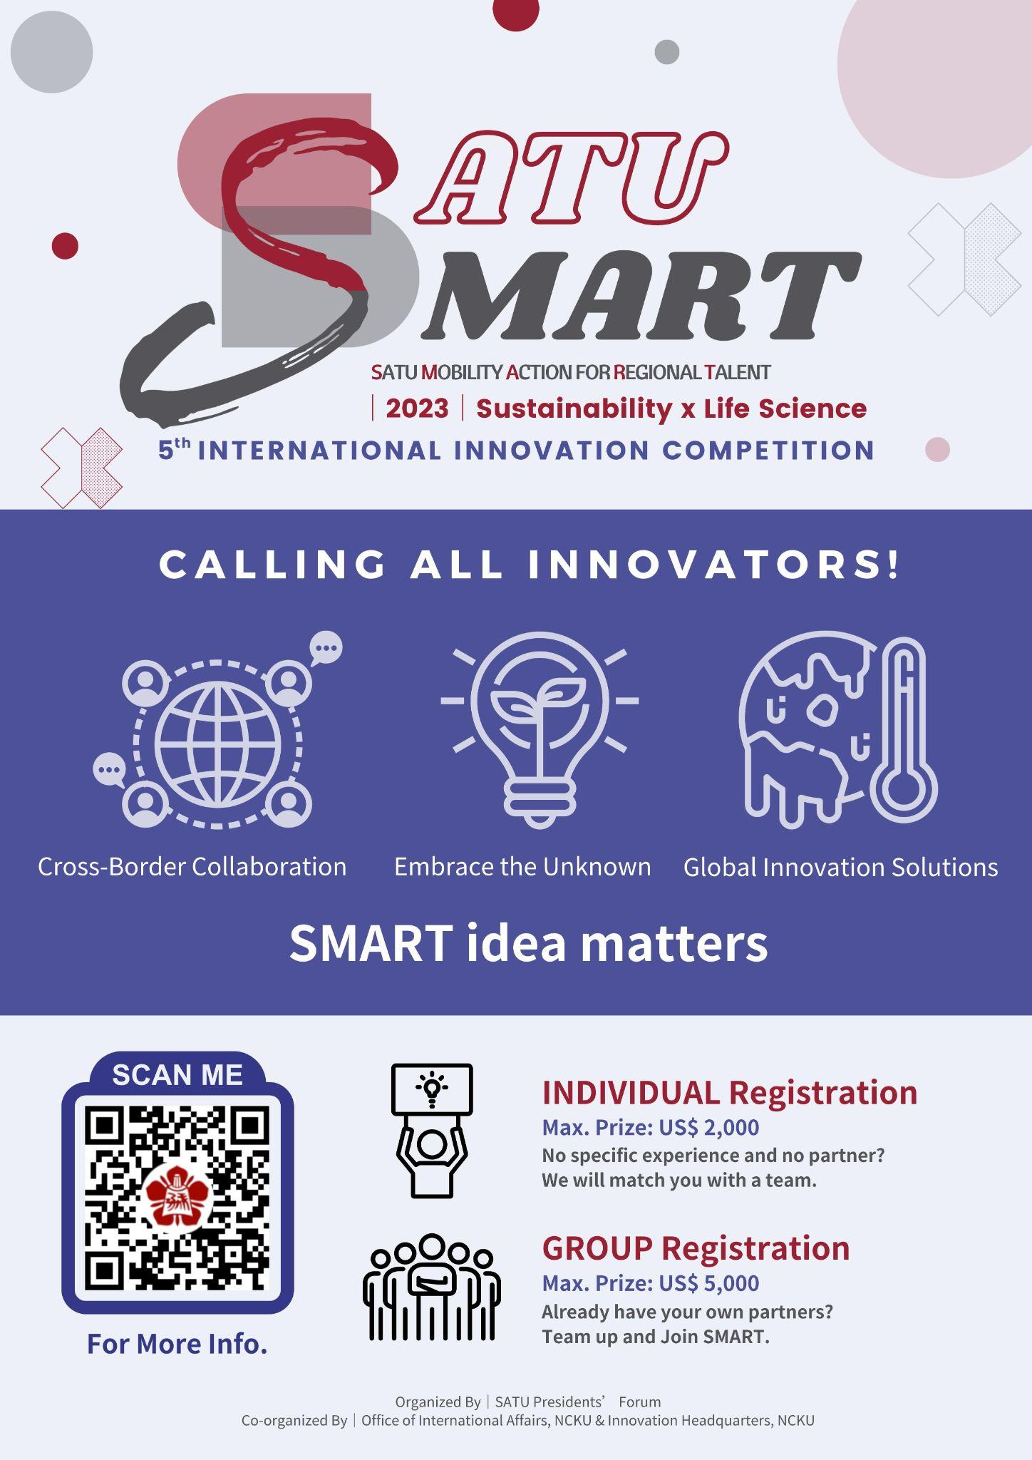

How to join
Individual Sign-Up or Group Sign-Up (2-5 members)
Further Details please visit 2023 SATU SMART Website: https://satu-smart.com/

Timeline
- Sign up period: From today until August 6th, 2023.
- (Individual participation only) Teams created by event staff: August 9th, 2023.
- Pitch deck and video pitch submission: October 5th, 2023.
- Finalist Announcement: October 30th.
- Online Final Presentation (LIVE): November 4th-5th, 2023.
- Announcement of Winners: November 7th, 2023.
- Online Award Ceremony at SATU General Assembly: Mid November, 2023.

Prizes
For Individual Sign Up
Gold Award: US$2,000
Silver Award: US$1,000
Bronze Award: US$500

For Group Sign Up
Gold Award: US$5,000
Silver Award: US$3,000
Bronze Award: US$1,000

Eligibility
Participant must be:
a student of a SATU member university (check to see if your university is listed HERE)

Further Details & Enquiries
For more details, please visit the 2023 SATU SMART Linktree or Website
Questions? Reach us by email :
✉ satu.smart.competition@gmail.com

Organized by
SATU Presidents’ Forum
Office of International Affairs, National Cheng Kung University
Innovation Headquarters, National Cheng Kung University

